Dear EDSA members,
EDSA designed a web page www.edsafamily.com a while ago to create a network between families who have child with Down Syndrome around the world. Families can host each other in their homeland using that platform by creating an invitaion or applying to an invitation.
We think that we can use the platform to help people from Ukrania who have to leave their homeland.
What you can do:
1- Please contact with your members and help them to create an account and invitation if they can host refugees from Ukraine.
2- If you know families from Ukraine please show that webpage (it is compatible with mobile devices) and help them to create an account to see invitations.
There is one trick for safety of both hosts and guests. All accounts should be approved by a member association listed in registration page. The platform is only for the people who known by an association so while creating an account users have to select the association which know them. And that association has to check its mail account to approve the new user.
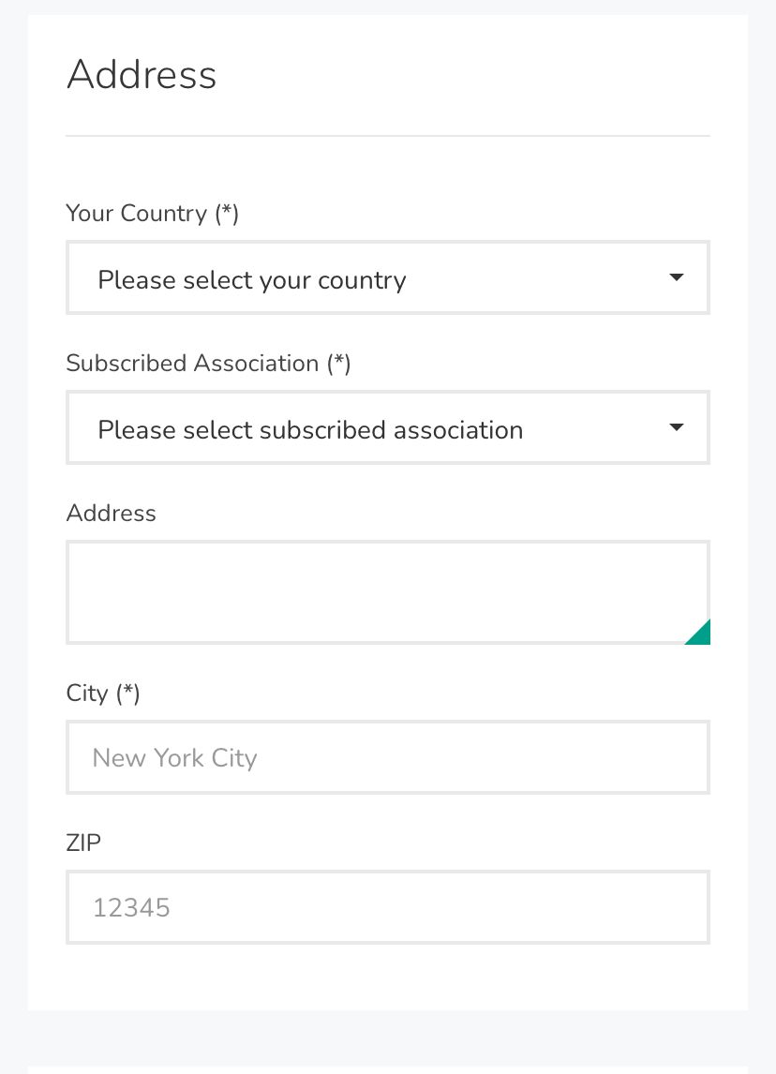
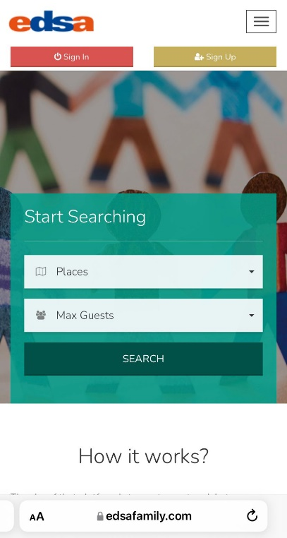

If you have more question don’t hesitate to ask. I believe this may help to solve accomodation problem but to do that you need to convince the families in your associations to create an account and invitation.
For questions and technical issues : fuya@downturkiye.org or edsa.eu@gmail.com

